KT Consolidated

# **Company data correction and migration**

This section related to company CMS data correction and reports extraction jira story.

1. <https://jira.refinitiv.com/browse/EAMEA-188> -- Riwa

Extract Zawya Ownership data file

https://jira.refinitiv.com/browse/EAMEA-189

Report enhancement for Ownership file

PE Sheet

Company Sheet

Officers Sheet

Family Sheet



1. Please refer EAMEA-392 present in Jira story and Script involved section
2. https://jira.refinitiv.com/browse/EAMEA-242 -- Riwa

Data Extraction for a sample of 100 companies

This request is needed for data analysis.

For the 100 attached Zawya IDs, please extract the company report.

 

1. https://jira.refinitiv.com/browse/EAMEA-229 -- Riwa

List of Companies from DB - Part of TRP/BRI

extract all companies linked to Projects (TRP/BRI) database



1. https://jira.refinitiv.com/browse/EAMEA-186 -- Riwa

Extraction of Associates (Subsidiaries and Investments only) for all Companies

extract Associates (for this request we only need “Subsidiaries“and “Investments” under Associates) linked to all companies (Active/Inactive/Trashed).



1. CC
2. VV

# **Officers data correction and migration**

This section related to Officers CMS data correction and reports extraction jira story.

1. We usually get mail request from Riwa/Tarun regarding live data extraction of

Officers list Active/Inactive reports

Officers position report

Telephone number of officers

Officer Position File

Phone Numbers File

Officers Active

Here live sql script attached

   

1. https://jira.refinitiv.com/browse/EAMEA-310

Officer Cleanup Lists – Zawya – Faten

Please refer EAMEA-310 present in Jira story and Script involved section

1. https://jira.refinitiv.com/browse/EAMEA-405

Split of Officer Name into Prefix, First, Middle, Last Name - Riwa

Please refer EAMEA-405 present in Jira story and Script involved section

1. https://jira.refinitiv.com/browse/EAMEA-392

Re-extraction of EAMEA-314

including the additional columns we requested in EAMEA 314 - Riwa

Please refer EAMEA-392 present in Jira story and Script involved section

1. https://jira.refinitiv.com/browse/EAMEA-298

Merging of Duplicate Officer IDs

Kindly merge the duplicate Officer IDs reported from column Duplicate ID1 till column Duplicate ID7 under the Main ID (which is column A: Original ID to keep).

 

# **Projects data correction and migration**

This section related to Projects CMS reports extraction jira story.

This is a manual process to extract all project CMS zawya data from live.

We want to extract the perm ID of the attached excel sheets from the jira .

So for the Project document we want to extract the company's perm id that are listed as CUSIP column D

As for the rest two excel documents (contract and sub-contract) the extractions need to be done from cms to extract the perm ids for the companies in participant section.

We used to receive sheets every week of month like below for august and September



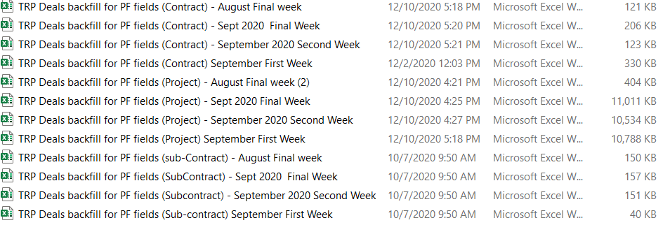

From zawya project CMS we extract the projects/contracts/subcontracts from all the sheets and provide below type of reports

For projects data extraction below steps to follow.

1. For all project related sheets (TRP Deals, projects) , need to populate the PERMID for all projects.

Tabs to consider

ProjectBasics

Concessions

Offtakes

**Query use to fetch the PERMID**

SELECT p.id_project,pt8.perm_id,pt8.id_company,pt8.company_name

from

PROJECTS p

left join PROJECTS_ROLE_MAPPING pe on pe.cde_role = 7 and id_project = pe.cde_project

left join company_name pt8 on pt8.id_company = pe.FOREIGN_ID

where p.id_project in (SELECT PROJECTID from TARUN.temp_proj_smarak);

1. Get all projects id from project sheet and put in a temp table and fire sql query to fetch all project related CMS sheets
   1. Proj_inf_proj_id
   2. Project Background and Scope
   3. Project Bidders
   4. Project Co_ordinates
   5. Project Schedule
   6. project vendor
   7. Project_contact_info
   8. Project_Participants
   9. JV_Project_Report
2. Get all contracts id from contract sheet and put in a temp table and fire sql query to fetch all contract related CMS sheets
   1. Contract OA_ID
   2. Contract Background and Scope
   3. Contract Bidders
   4. Contract Participants
   5. Contract Schedule
   6. Contract Vendor
   7. Contract_co_ordinates
   8. Contract_Project_contact_info
   9. JV_Contract_Report
3. Get all contracts id from sub contract sheet and put in a temp table and fire sql query to fetch all sub contract related CMS sheets
   1. sub Contract Bidders
   2. Sub Contract OA_ID
   3. Sub Contract Schedule
   4. Sub Contract Vendor
   5. Sub Contract_co_ordinates
   6. SubContract Background and Scope
   7. subContract Participants
   8. subContract_Project_contact_info

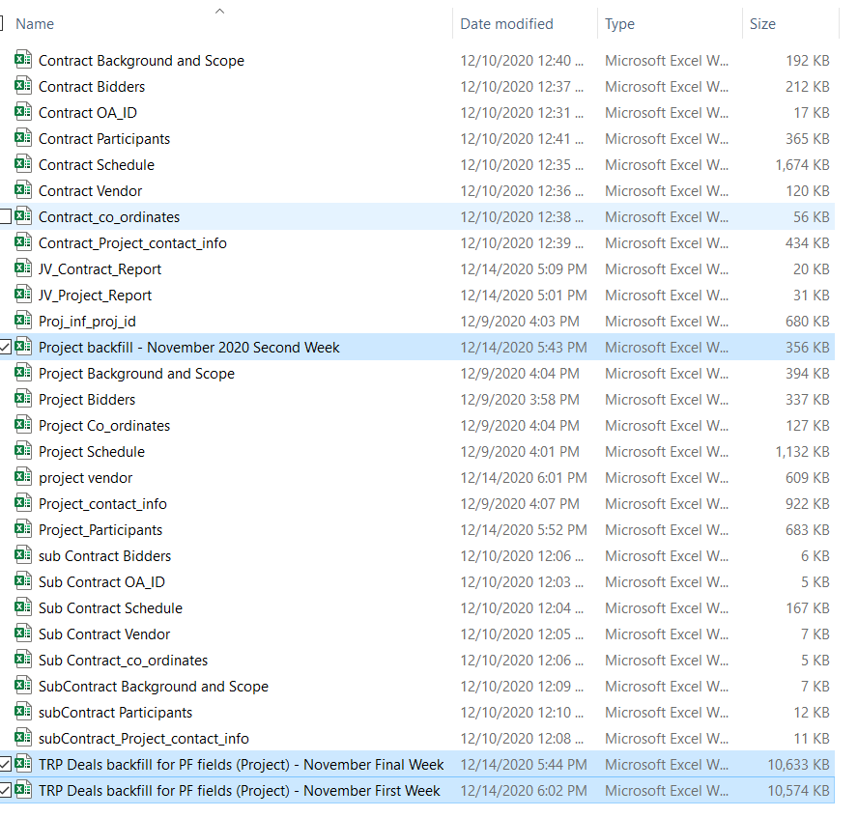

All high lighted sheets we need to populate the PERMID against each project.

Process to follow for extraction

1. Insert all the projects in a temp table and Use that table in the query to fetch the project related reports
2. Remove the projects from temp table
3. Insert all the contracts in a temp table and Use that table in the query to fetch the contracts related reports
4. Remove the contracts from temp table
5. Insert all the subcontracts in a temp table and Use that table in the query to fetch the sub contract related reports

# **Stakeholders involved**

1. For RPA projects data correction, below stakeholders involved

Shadi/Jan

1. For company data correction below stakeholders involved

Riwa

1. For officer data correction below stakeholders involved

Riwa

# **Jira story involved**

Please refer below jira stories which i have worked on

* + - 1. https://jira.refinitiv.com/browse/EAMEA-386

PERM ID Upload on Zawya Backend for 7,843 companies – Riwa

* + - 1. https://jira.refinitiv.com/browse/EAMEA-405

Split of Officer Name into Prefix, First, Middle, Last Name - Riwa

* + - 1. https://jira.refinitiv.com/browse/EAMEA-336

PERM ID Upload on Zawya Backend for 21,967 companies – Riwa

* + - 1. https://jira.refinitiv.com/browse/EAMEA-392

Re-extraction of EAMEA-314

including the additional columns we requested in EAMEA 314 - Riwa

* + - 1. https://jira.refinitiv.com/browse/EAMEA-310

Officer Cleanup Lists – Zawya – Faten

# **Scripts involved**

1. EAMEA-386, EAMEA-336

  

2. EAMEA-405

   

3. EAMEA-392

 

4. EAMEA-310



# **References**

Refer here.

# **Questions and review comments**